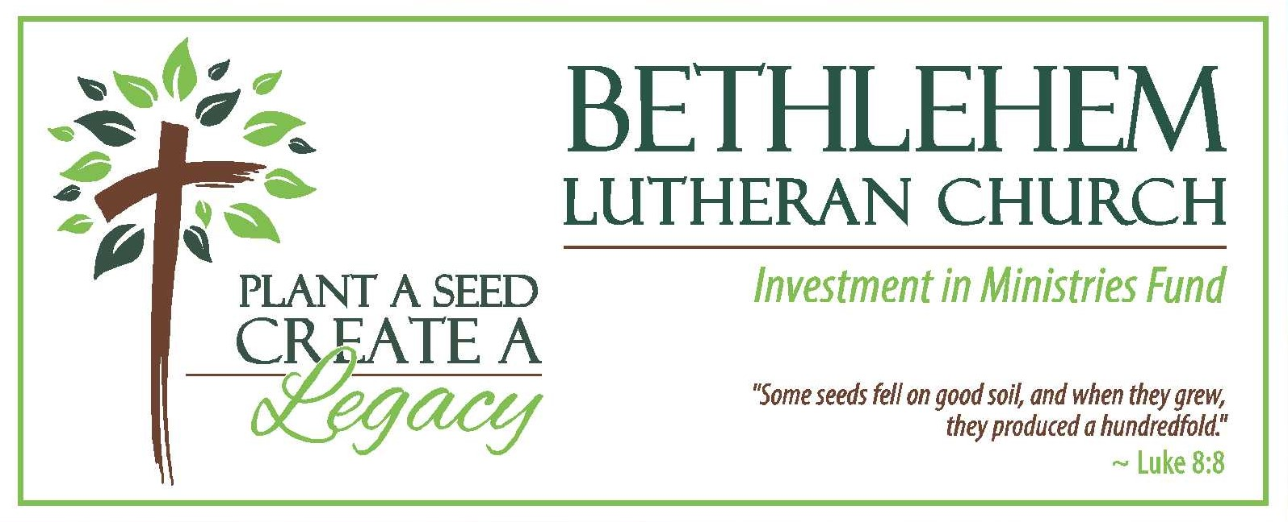
June 1, 2022
Dear Members and Friends of BLC,

The Investment in Ministries Fund Committee is pleased to announce that Bylaws to establish the Investment in Ministries Fund (IMF) were approved by the congregation on May 15 at the special congregational meeting. At the meeting, the congregation also affirmed the Council’s decision to allocate $25,000 from the Memorial Fund to initiate the IMF. The funds will be invested in the ELCA Ministry Growth Fund, a socially responsible fund of the ELCA Foundation. As a reminder, the purpose of the IMF fund is to support ministries and missions for people who are not members of Bethlehem Lutheran Church through annual withdrawals.

As we move into The NEXT 100 Years, we will carry on the tradition of generosity that has become so characteristic of our congregation. In addition to your regular giving, we hope you will consider making a special donation to celebrate BLC’s 100th anniversary, perhaps in memory or honor of someone close to you, at whatever level you feel most comfortable. No gift is too big; no gift is too small.

We have enclosed a special envelope for your donation. You can place it in the collection plate or mail to: Bethlehem Lutheran Church c/o Investment in Ministries Fund, 48 Perrin Street, Fairport NY 14450. We appreciate your generosity and thank you for your participation in this significant event in our church history.

We also hope you will consider including the IMF in your will or estate plan. We will make additional information available over the coming months.

On Sunday, June 5th, our ELCA Regional Gift Planner, Ryan Ebner, will be here at BLC to discuss Legacy Planning with the congregation. Ryan is well versed in legacy giving options and is willing to meet in-person or via Zoom to discuss your personal situation.

Thanks for all you do to be Christ’s hands and feet in the world.

Peace,

BLC Investment in Ministries Fund Committee
Paulette Costanza, Mark Gaul, Roger Kolker, John Costanza, John Panko

